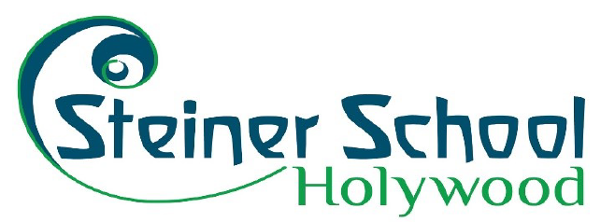

CALL FOR BOARD MEMBERS

HOLYWOOD STEINER SCHOOL
34 Croft Road Holywood, BT18 0PR

We are in an exciting period of development at our school and are now looking for experienced individuals to join the Board of Trustees to help us deliver on our ambitions.

If you are interested in enhancing your own skills and/or supporting an innovative and truly effective educational approach, then this could be the opportunity for you.

As Trustees of a charity, we are an operational Board, providing each Trustee with the opportunity to get involved in helping to deliver our charitable objectives.

Please click below or follow the link for further information and a copy of
Strategy 2025
[www.holywood-steiner.co.uk/strategy2025]

Note that the deadline for applications is 27 January 2023

About Holywood Steiner School

The Holywood Steiner School was founded in 1975, our beautiful campus overlooking Belfast Lough is situated five miles east of Belfast in Holywood, County Down. We are a mainstream independent, coeducational school, welcoming students from ages 3-17. Our School is rooted in a tolerant and diverse community, with a variety of cultures represented.

We deliver the Waldorf curriculum and are members of the Steiner Waldorf Schools Fellowship, the representative body of Steiner Waldorf schools in the UK. The school prides itself on delivering a curriculum that enables the pupils to build successful lives on foundations of active learning, experiences and resilience.

Our focus is on developing each child or young person to maximise their abilities in the widest sense. We use imaginative methods to foster a love of learning and skills that are fundamental for their future.

The school has recently been inspected by the Education and Training Inspectorate and received a very positive report (available at www.etini.gov.uk/publications/independent-school-inspection-rudolf-steiner-co-educational-independent-school-holywood)

Board Member Role

The Board of Trustees work with the Head teacher and Staff of the school to ensure that it is effectively run, whilst affording pupils an outstanding educational experience. As a trustees of an independent school, we have a greater responsibility to monitor health and safety and ensure robust Child Protection policies and procedures are up to date and adhered to. The Board is responsible for guaranteeing the School operates within best practice guidelines. Board members are advocates for Holywood Steiner School and expected to ensure good governance in their endeavors

As a member of the Board, you will be required to:
- Participate in strategic planning for the development of the school
- Monitor Holywood Steiner School’s performance against agreed objectives as laid out in Strategy 2025
- Be advocates of Holywood Steiner School
- Have knowledge and skills in areas relevant to the running of a charity
- Ensure the good governance in all areas of the charity and the delivery of its objectives
- Oversee and approve financial reports and annual accounts
- Attend Board Member training as required.
- Attend monthly Board meetings and the Annual General Meeting
- Identify opportunities for funding and income generation
- Support (and participate in) fundraising events
- Participate in Board sub-committees as required in the following areas:
  - Finance
  - HR
  - Development

Board Member Person Specification
Successful candidates will have evidenced experience in at least one of the following areas:
- Development
- Project Management
- Marketing and/or PR and communications
- Business development
- Fundraising
- Finance
- HR
- Education
- Community engagement and outreach
- Previous Board or management experience (preferable but not essential)
- A background and/or knowledge in Steiner education would be advantageous.

Benefits of becoming a Board Member of Holywood Steiner School
- Instrumental in the provision of the innovative education of young people
- Involvement in the ongoing development of the school
- Development of knowledge and engagement with an international Steiner community
- Development of team-working and project management skills
- Increased experience in funding and income generation
- Governance training
- Sharing knowledge and experience for the benefit of others.
- Benefitting the local and wider community through education.

To apply, please email a covering letter detailing your area of expertise, what you feel you will contribute to the Holywood Steiner School Community, along with an up to date CV, by noon on 27th January 2023 to The Chair, Caroline Ball, chair.trustees@holywood-steiner.co.uk

Please note it is anticipated that applicants will be selected by interview process, aiming to conclude this and appoint of new Board members by mid-February 2023.

There is no renumeration associated with a Board position.

Holywood Steiner School aims to promote equality & diversity and encourages applications for board membership from all communities.

